Akshat Thirani EECS 395: ML

Tigist Diriba 9th Feb 2015

Project Proposal

We are interested in investigating Machine Learning algorithms for object recognition and classification using Computer Vision. Some potential algorithms include using SVMs, Gaussian Mixture Models, and Neural Networks. Currently we are contemplating whether to use well-known image features or to learn new features from a large dataset. An application we are considering is the recognition of tools, such as a hammer or drill. We plan on creating a database of sample images by web-scrapping. The algorithm must be able to robustly differentiate between similar-looking objects.

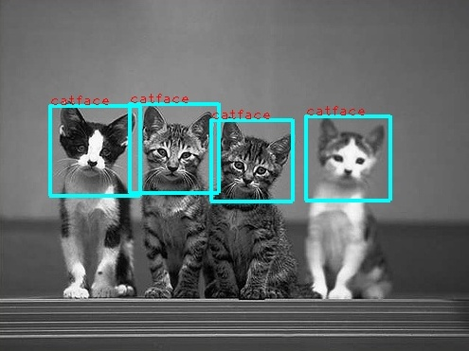

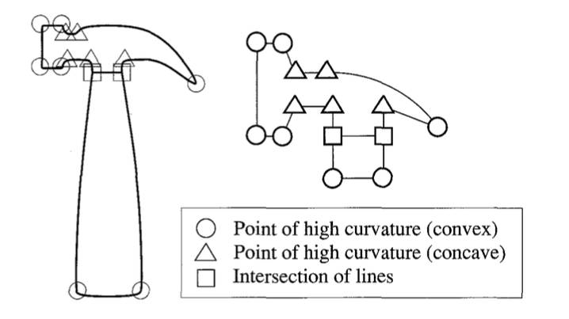

Bibliography:

* http://cbcl.mit.edu/cbcl/publications/ps/heisele-x3hei.lo.pdf
* http://www.cv-foundation.org/openaccess/content_cvpr_2014/papers/Erhan_Scalable_Object_Detection_2014_CVPR_paper.pdf
* http://www.cse.usf.edu/~r1k/MachineVisionBook/MachineVision.files/MachineVision_Chapter15.pdf
* http://papers.nips.cc/paper/5207-deep-neural-networks-for-object-detection.pdf